SYSTEMS DIVISION

IPD END Of Day Cleanup
TEST PLAN DOCUMENT
WR # 2111

DRAFT

Prepared By:
Back Office IPD Team

1. END OF DAY CLEANUP test 4
1.1. END OF DAY CLEANUP test 4
1.1.1. Test Description: 4
1.1.2. Test Environment 4
1.1.3. Expected Results 4
1.1.4. Actual Results 4

END OF DAY CLEANUP Test

End Of Day Cleanup Test

Test Description:
The End Of Day Cleanup inactivates (sets the list state to inactive by inactivation date analysis) for PROD_CLASS, RPT_CLASS, non option future products (PRODUCT), option/future AM products (PRODUCT), and option/future PM products (PRODUCT), as well as generating orphan reports. It deletes all the move/applied records for the following tables. PROD_ADJ, RPT_CLASS_ADJ, and PRICE_ADJ. It also deletes all the records for the following tables: IPD_OPT_SERIES_CHG, BUS_DAY, QUEUETABLE, QUEUEELEMENTTABLE, and QUEUEELEMENTDATATABLE.

Test Environment
IPD and ipdsd000.

Expected Results
- Make sure the list state code is inactive for all PROD_CLASS, RPT_CLASS, and PRODUCT records whose inactivation date is less than the next trading day.
- Make sure that the following tables are empty: IPD_OPT_SERIES_CHG, BUS_DAY, QUEUETABLE, QUEUEELEMENTTABLE, and QUEUEELEMENTDATATABLE.

Actual Results
The data in the IPD tables.
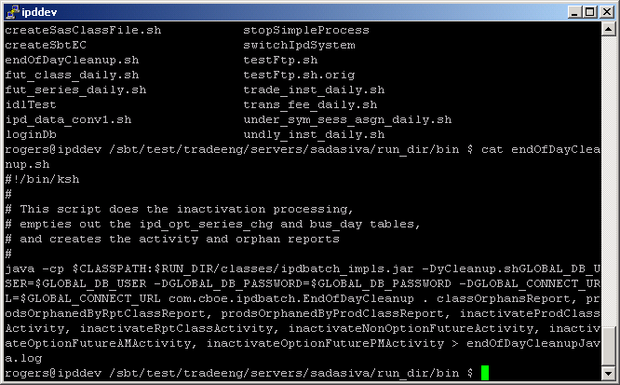

This is the unix script endOfDayCleanup.sh. The default next trading day is obtained from the table bus_day. If another trading day is needed it can be added to the end of the execution line in
DD-MMM-YYYY format, for example 23-Oct-2005. This script will run the end of day process for the IPD data base.

